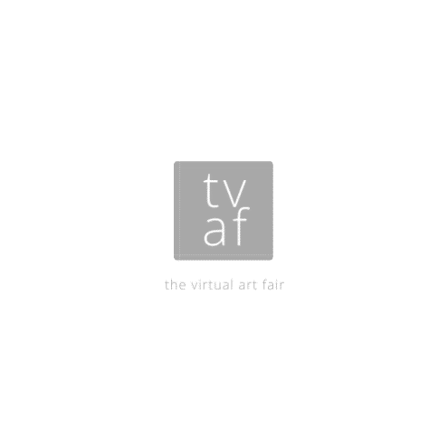 | The  Virtual  Art Fair  Fourth Edition  4 December 2020

Application

About You
Name:
 | Last | First | Artist Name: (preferred)

Email: |  | Website:

Instagram: | @ | Facebook.: | @ | Twitter: | @

Where are you based: | e.g Birmingham, UK

Artist Biography (please write in third person)
80 – 200 words

About Your Space
How much space would you like to display your work? Please tick
1 Metre | 2 Metres | 3 Metres | 4 Metres

About Your Artwork
Please fill in the below information about the artwork you are displaying. Please repeat if required.
Title |  | Year:
Medium:
Dimensions: | Please give unframed dimension in cm. Sizes must be accurate to show accurate scale in gallery
Is this work for sale? | YES | NO | Price: | £

Title |  | Year:
Medium:
Dimensions: | Please give unframed dimension in cm. Sizes must be accurate to show accurate scale in gallery
Is this work for sale? | YES | NO | Price: | £

Title |  | Year:
Medium:
Dimensions: | Please give unframed dimension in cm. Sizes must be accurate to show accurate scale in gallery
Is this work for sale? | YES | NO | Price: | £

Title |  | Year:
Medium:
Dimensions: | Please give unframed dimension in cm. Sizes must be accurate to show accurate scale in gallery
Is this work for sale? | YES | NO | Price: | £

Title |  | Year:
Medium:
Dimensions: | Please give unframed dimension in cm. Sizes must be accurate to show accurate scale in gallery
Is this work for sale? | YES | NO | Price: | £

Title |  | Year:
Medium:
Dimensions: | Please give unframed dimension in cm. Sizes must be accurate to show accurate scale in gallery
Is this work for sale? | YES | NO | Price: | £

Sending Your Application & Images

Please label each image with your name, title of work, medium, dimensions, price

For example: LucyMorrison_OilonCanvas_200cmx150cm_WoodedPath_£1500.jpeg

Please make sure your images are no bigger than 1.5MB each and in JPEG format. Please crop out frames or backgrounds. All works will be displayed in the virtual art fair without frames.

Disclaimer and Signature
I have read the terms & conditions and agree to that my images will be used as part of the Virtual Art Fair Virtual Gallery which will be featured on ArtSteps online site.
Signature: |  | Date:

Please send your completed application form and images to thevirtualaf@gmail.com

Deadline: Sunday 15th November, 5pm

Follow us on Instagram - @thevirtual.artfair @lfmartworks
Follow us on Facebook - @thevirtualartfair

FAQ’s

Is there a fee?

No, this is a free event and no commission is taken from any sales. This is a free platform for artists to showcase their works and it is down to the individual Artist to facilitate any sales. Any individual that is interested in buying your work will be directed to the Artist’s website or email to make a direct purchase.

My work is framed. Can my work be shown frame?

All artworks will be shown unframed in the Virtual Art Fair.

Is there a size limit for works?

Works are shown to scale in the virtual room. The virtual wall panels can be from 1m wide to 4m wide, but the height is limited to 3m.

Can I submit sculpture or 3D works?

No but we are working on how we can incorporate this in the future. Please get in touch if you are interested in showing your sculpture.

Is there a limit on how many artworks I can show?

Once you have selected your space please try and only submit works that will fit within your space. For example, if I have a 2 metre space and my paintings are 30cm x 30cm I know I can fit 5 in a row with 5cm between each painting and 15cm on the outside. The Virtual Art Fair will arrange the works on your board but please make sure you only submit what you know will fit on your chosen board panel.

Where will The Virtual Art Fair be shown?

The Virtual Art Fair will be shown on Artsteps.com
It will also feature on @thevirtual.artfair on Instagram and Facebook @thevirtualartfair. Each Artist will be sent a link where they can either share the Virtual Art Fair on their social media or embed it in their website. The more people that share the virtual space the more people will see your work. Artists need to stick together - so let’s put on one heck of a show!

Terms & Conditions

Definitions

Organiser: Lucy Morrison on behalf of The Virtual Art Fair

Exhibitor: The Artist or Artists allocated space in The Virtual Art Fair

Fair: The Virtual Art Fair

Wall Space: The area of the fair allocated to the exhibitor as outlined in the About Your Space section

Contract: Means any contract between the Organiser and the Exhibitor for the allocation of the wall space incorporating ‘terms & conditions.

1. The Fair

- The Fair will be hosted on ArtSteps.com
- The Fair will be online until the Organiser takes it down. The Organiser has the right to take down the Fair without notice.
- There are no fees or commission taken whilst exhibiting at the Fair. If artwork is for sale it is up to the Exhibitor to facilitate payment and delivery to the customer.

2. Applications

- The Organiser reserves the right to refuse any application for the Fair without explanation.
- The Exhibitor can request to leave the Fair at any point and their artwork will be taken down from the Fair.
- The signing of the Application Form is an acceptance of these Terms & Conditions

3. Images

- The Exhibitor must supply the Organiser with images they would like to exhibit. If work is defamatory or distasteful to a family audience, it will not be exhibited in the Fair.
- The Organiser is free to use the said images to promote the fair in advertising material and all forms of social media.
- All images will be featured on ArtSteps.com

4. Organiser’s Liability

- The Organiser shall not be liable for any loss or damage (including consequential or indirect loss or damage arising from the Organiser’s negligence) and which shall include (but not by way of limitation) loss of profits, loss of contracts, loss or damage to goods or property of the Exhibitor or any other person.

